📌 Day 2 – Database Design & Entity Development
Project: Job Tracking Application

1️⃣ Objective
Design a structured, scalable, and relational database schema to support the job tracking workflow and implement core entities in the backend.

2️⃣ Database Design Approach
The database is designed to:
- Maintain clear role separation
- Support job-to-application relationships
- Ensure referential integrity
- Allow scalability for future enhancements
- Optimize query performance
Database Type: MySQL (Relational Design)
Architecture: Normalized Schema (3NF)

3️⃣ Core Tables Designed
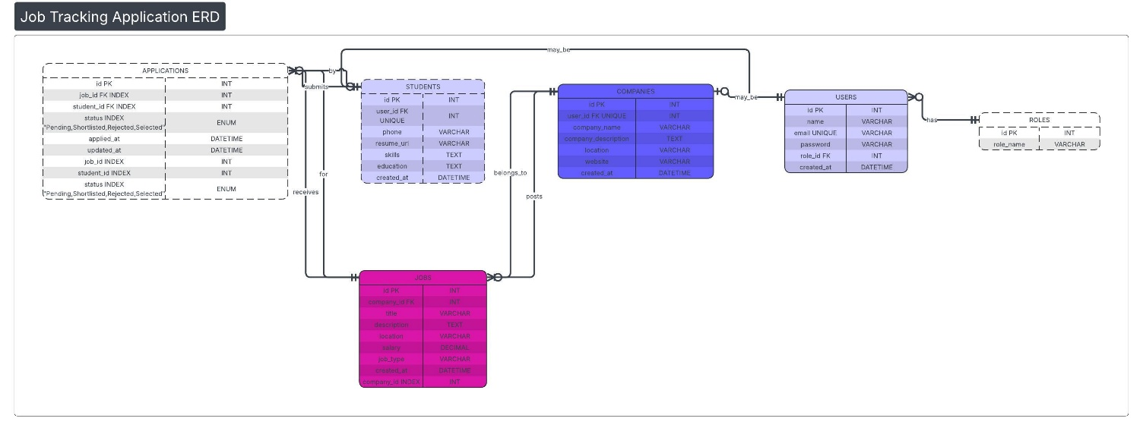

1️⃣ Users Table
Stores common user authentication data.
Fields:
- id (PK)
- name
- email (Unique)
- password
- role_id (FK)
- created_at

2️⃣ Roles Table
Defines user roles.
Fields:
- id (PK)
- role_name (ADMIN / COMPANY / STUDENT)

3️⃣ Students Table
Stores student-specific information.
Fields:
- id (PK)
- user_id (FK)
- phone
- resume_url
- skills
- education
- created_at

4️⃣ Companies Table
Stores company profile data.
Fields:
- id (PK)
- user_id (FK)
- company_name
- company_description
- location
- website
- created_at

5️⃣ Jobs Table
Stores job postings created by companies.
Fields:
- id (PK)
- company_id (FK)
- title
- description
- location
- salary
- job_type
- created_at

6️⃣ Applications Table
Stores job applications submitted by students.
Fields:
- id (PK)
- job_id (FK)
- student_id (FK)
- status (Pending / Shortlisted / Rejected / Selected)
- applied_at
- updated_at

4️⃣ Relationships Defined
- One Role → Many Users
- One User → One Student or One Company
- One Company → Many Jobs
- One Job → Many Applications
- One Student → Many Applications

5️⃣ Database Constraints Applied
✔ Primary Keys
✔ Foreign Keys
✔ Unique Constraint on Email
✔ Indexes on:
- job_id
- student_id
- company_id
- status
This ensures:
- Faster filtering
- Optimized joins
- Data consistency

6️⃣ Backend Entity Development
Implemented:
- JPA / ORM Entity Classes
- Repository Interfaces
- Proper relationship mappings:
  - @OneToMany
  - @ManyToOne
  - @OneToOne
Applied:
- Cascade types where necessary
- Fetch strategies (Lazy loading)

7️⃣ Sample Data Inserted
Created test records for:
- Admin user
- Sample company
- Sample student
- Sample job
- Sample application
Performed SQL join testing to verify:
- Job + Company relationship
- Application + Student relationship
- Application + Job relationship

8️⃣ Validation & Data Integrity
- Email uniqueness enforced
- Foreign key constraints tested
- Null restrictions applied to required fields
- Status field controlled via enum

9️⃣ Performance Considerations
- Indexed frequently queried columns
- Optimized relationship design
- Avoided redundant data storage
- Designed scalable schema for dashboard analytics

🔟 Deliverables Completed on Day 2
✔ Complete relational database schema
✔ Table creation with constraints
✔ Entity class implementation
✔ Repository layer setup
✔ Sample data insertion
✔ Join testing and validation
✔ Optimized indexing strategy

